Step to follow

Draw S&R as explained earlier

After drawing it draw trendline

And identify the major location for all those price movement i.e change in direction etc

Now use your 1hr overlapping to find in which direction you have to plan trade ,

Pura kahani samjhne k baad direction dekhna h..

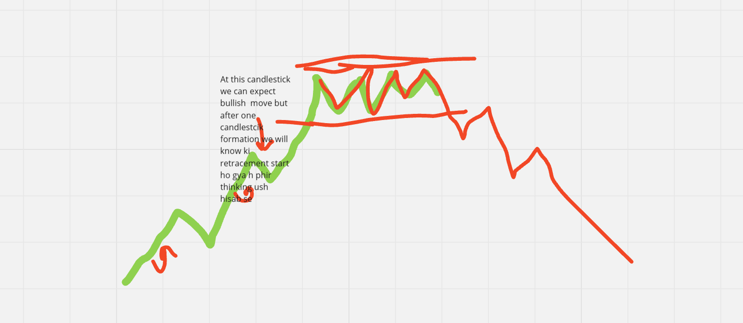Kahani kuch bhi ho

Give importance to support and resistance

Kyu ki that are main zone

So if candlestick is saying something which is against your support and resistance zone, trendline then give importance to those and do not plan trade …..

So lets give conclusions LIKE

1.Draw support and resistance (top down)

2.Trendline draw in 1hr time frame

Now You are clear with the important zone

3.Now come to 1hr time frame and understand the complete story

a.understanding 3 overlapping candlestick

b.identify its location like

\*around support and resistance

\*around trendline

\* in retracement phase

4.Now suppose everything you watched is good condition can fail when you expectected bullish move for next hour but currently we are the starting of retracement so

It is there in the fig so if you have planned bullish move but currently it is bearish bcz of start so mostly you will not find trade there

So now you are done with everything

Now you have to enter the trade

Englufing and hammer around s&R ,hammer also

If we have missed it then we will plan this near you have to enter the market at the end of retracement

Retracement start can be identified when there is loss in momentum

So sometime loss in momentum is low time frame it means the candlestick indicating bullish like in bullish move formation of hammer so

Here you can do one thing in general i.e good move me kitna move krta h usse compare karo the idea lg jaye but agr koi NEWS h market me then isse kuch nahi hoga…

For Any index you are trading just see ki koi to time aisa hoga jisme there is no such news any thing market ideally move kiya hoga odhr se move dekh lo phir kya usse compare karo

So analyse and find that percentage or you can even code..